**MEGN 200 – Worksheet 4**

**Servo Motor and Temperature Control System**

In this activity, we’ll use a Thermistor (temperature sensitive resistor) to measure temperature and a servo motor to adjust the angle of an output arm. Then, we’ll combine the Thermistor, Servo Motor, and DC Motor to create a simple temperature-based cooling control system.

# Deliverables (20 Points Total)

1. **Link a video showing and verbally explaining** **all of the features** of the servo motor and IR remote code working when each button is pressed multiple times (be sure to include your face). **(5 pts**)

Video link here

1. **Paste a screenshot of your Matlab plot showing the thermistor temperature data** after placing the device in your refrigerator/freezer for 5 minutes and back at room temp for 5 minutes. **Write below how long it took for the sensor to reach the min temperature and get back to the max temperature (were the times different, and if so, why might that be?).** (**5 pts**)

Insert screenshot of the 10 min. temperature Matlab plot here and discuss the times required to cool to the min and heat to the max temperatures.

1. **Link a video showing and verbally explaining** the working temperature control system code and Serial Plotter/Monitor (be sure to include your face). (**5 pts**)

Video link here

1. **Answer the following questions** (**5 pts**):
   1. What is the purpose of the Serial Monitor and Plotter? How did you collect the temperature data over time? Why might this data collection technique be useful?
   2. How does the IR remote control transmitter and receiver work (do some online research)?
   3. What is the purpose of a servo motor? Why would you use a Servo Motor vs. a typical bare DC motor like the one in your kit?
   4. How long did it take for the thermistor to cool down without the fan vs. with the fan? Why does the fan help the thermistor cool more quickly (hint: do a little research on “thermal convection”)?
   5. What is a [voltage divider](https://learn.sparkfun.com/tutorials/voltage-dividers/all) and why was it important to create one using the thermistor and a 10k Ohm resistor to read temperatures?

# Part 1

Servo Motors are DC motors with a gearbox and built-in feedback control to position the output. The Servo in your kit has a tiny DC motor, a plastic gearbox, a motor driver, and an output gear for output arms all in a tiny form factor. Servos like this are common in RC cars, planes, and boats (see pictures below) to position an arm at a desired angle to help steer or guide the device. You may also find servos commonly used as a locking/unlocking mechanism and in many automated systems.

Typical Servos (like the one in your kit) are a type of geared motor that can only rotate 180 degrees, though some have different rotation ranges or can be configured for continuous rotation. It is controlled by sending electrical pulses from one of the PWM pins on your Arduino UNO R3 board. These timed pulses tell the servo what position it should move to. The Servo has three wires, of which the brown one is the ground wire and should be connected to the GND port of UNO, the red one is the power wire and should be connected to the 5v port, and the orange one is the signal wire and should be connected to a PWM-capable digital pin (like digital pin #9 in this example).

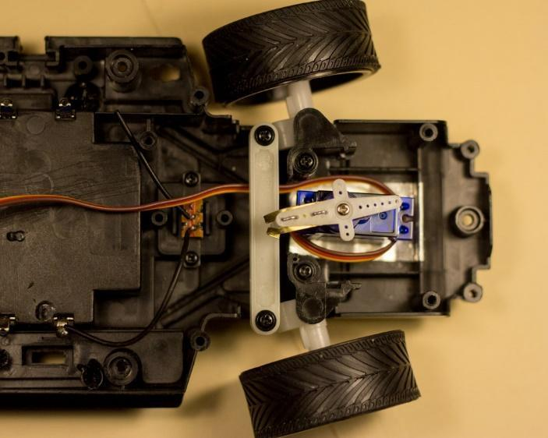

In this activity, we’ll also use an infrared (IR) remote to control the servo. IR remotes use an infrared LED to communicate information over a distance. When you push a button on the remote, the IR LED at the front of the remote lights up in a series of pulses. Each button on the remote produces a unique set of long and short pulses. An IR receiver is used to detect the pulses. Based on the pattern of pulses the IR receiver detects, we can determine which button was pushed on the remote. Your kit includes an IR remote and receiver that work together, but the IR receiver is capable of reading pulses from any IR remote, so you can control projects with your TV remote if you’d like!

Build the following circuit on your board to read the IR remote and control the servo. The IR receiver comes on a small circuit board with header pins that plug into the breadboard. The pins are labeled G, R, and Y. Connect G to ground, R to +5V, and Y to pin 11 to read the data from the receiver. The servo has three wires. They are Brown: ground, Red: +5V, and Orange: signal. Connect the signal wire to pin 9.

**Wiring Diagram:**

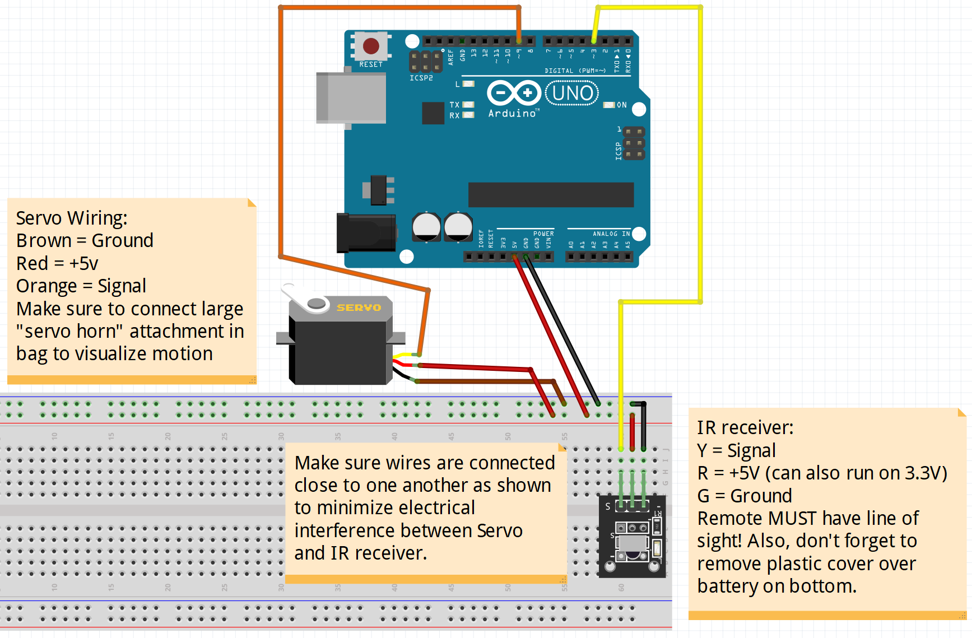

**Picture:**

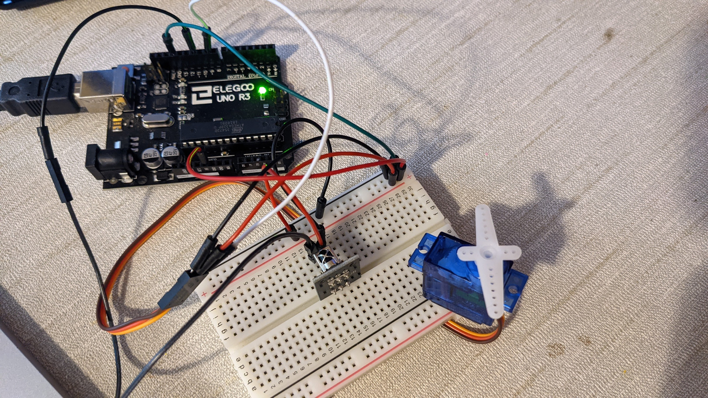

**Code:**

Test your servo by opening File > Examples > Servo > Sweep. If you upload this code, the servo should sweep back and forth. If the servo does not move, double check the connections to the servo to make sure they are correct.

**Next, make sure to install the latest version of the IR Remote Library** (Tools -> Manage Libraries… -> search for “irremote”, install v3.4.0 by Armin Joachimsmeyer, see picture below):

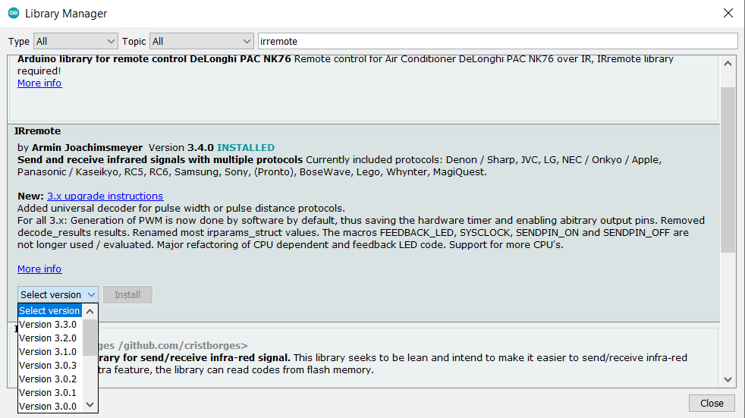

Next, download and open the “**ir_remote_servo_starter**” code and upload it to the board. Make sure that your Serial Monitor is using the default baud rate of 9600 to enable the use of the Serial Monitor. When you upload the code and press a button on the IR remote, you should see a red LED on the IR receiver flash and a number appearing on the Serial Monitor. The number is the code that the button on the LED produces. You should see different numbers when you press different buttons on the remote. Find the codes that correspond to the following buttons and write them in the table below:

|  |  |
| --- | --- |
| Power |  |
| Volume up |  |
| Volume down |  |
| Fast Forward |  |
| Rewind |  |
| Up arrow |  |
| Down arrow |  |

Next, change the switch-case structure in the code to control the position of the servo. The switch-case structure executes different commands based on the value of the variable ir_command. If the number after the keyword case matches the value of ir_command, then the Arduino will execute the instructions on that line of code. Set up the switch-case structure so that the following buttons have these functions:

**Power:** Moves the servo to 90 degrees

**Fast forward:** Moves the servo to 180 degrees

**Rewind:** Moves the servo to 0 degrees

**Up arrow:** Moves the servo by the number of degrees stored in the variable increment in the positive direction

**Down arrow:** Moves the servo by the number of degrees stored in the variable increment in the negative direction

**Volume up:** Make the value of increment larger, so the arrows move the servo more quickly

**Volume down:** Make the value of increment smaller, so the arrows move the servo more slowly

Additional if statements are needed to ensure that the servo position is not greater than the max angle of 180 degrees and not less than the min. angle of 0 degrees. Also, the increment can’t be less than the minimum angle step value of 1.

**Deliverable**:

Take a video showing your face which shows the code and demonstrates the working Servo + IR remote (put video link on deliverables pg. 1-2).

--

***Just for fun***: After you finish this exercise, try to see if you can read values using the IR receiver through the Serial Monitor by pressing buttons on an actual TV remote or another IR remote!

# **Part 2**

There are many different types of temperature sensors. Examples include Thermistors, Thermocouples, and Digital Temperature Sensors (like the DHT11 sensor you also have in your kit). For this exercise, we’ll use the Thermistor from your kit which looks like the image below (it’s in the little bag with the photocell and push buttons):

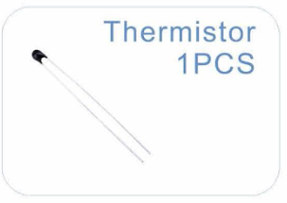

A thermistor is a thermal resistor, or a resistor that changes its resistance with temperature. Technically, all resistors are thermistors - their resistance changes slightly with temperature - but the change is usually very small and difficult to measure. Thermistors are made so that the resistance changes drastically with temperature so that it can have 100 ohms or more per degree of temperature change!

There are two kinds of thermistors, NTC (negative temperature coefficient) and PTC (positive temperature coefficient). In general, you will see NTC sensors used for temperature measurement. PTC's are often used as resettable fuses - an increase in temperature increases the resistance which means that as more current passes through them, they heat up and 'choke back' the current, which is handy for protecting circuits!

To use your thermistor, wire the following circuit. The blue wire which reads the voltage drop across the thermistor is connected to analog pin A0. Please note that the resistor in the wiring diagram needs to be a **10k** (10,000) **Ohm** resistor to get accurate and calibrated temperature readings from the thermistor based on the equation in the code. This is because the thermistor and the 10k Ohm resistor create [a simple circuit called a voltage divider](https://learn.sparkfun.com/tutorials/voltage-dividers/all). Since the thermistor changes resistance by a certain amount with changes in temperature, the known 10k Ohm resistor enables a simple relative voltage drop measurement across the resistor where voltage drop is calibrated to temperature.

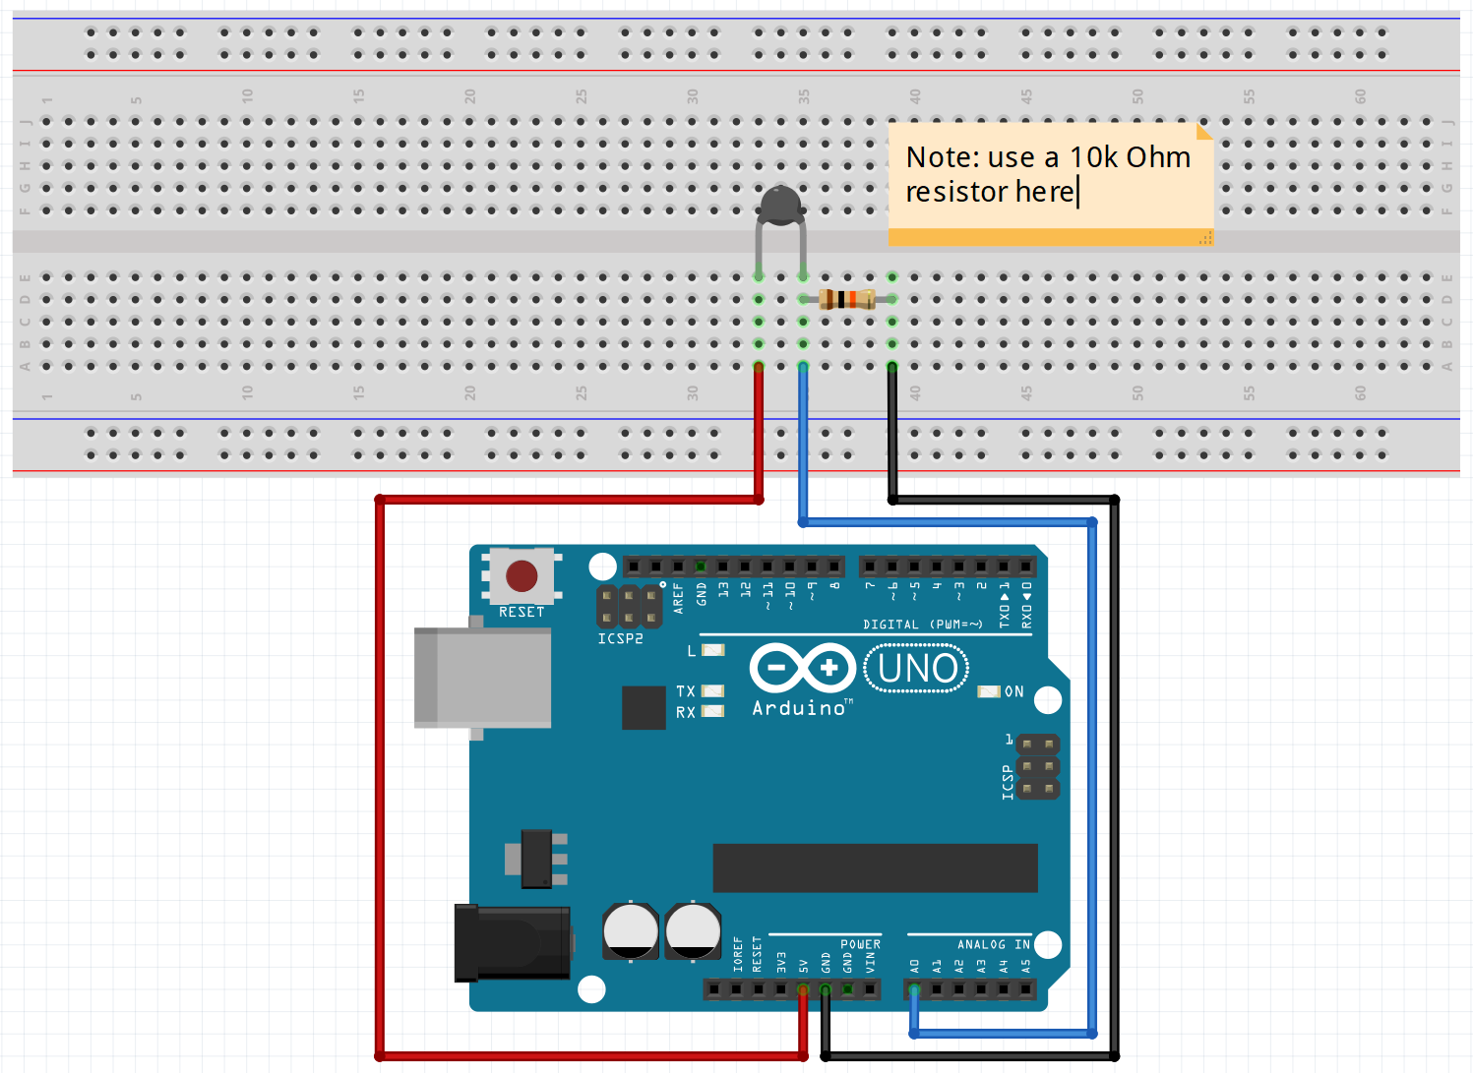

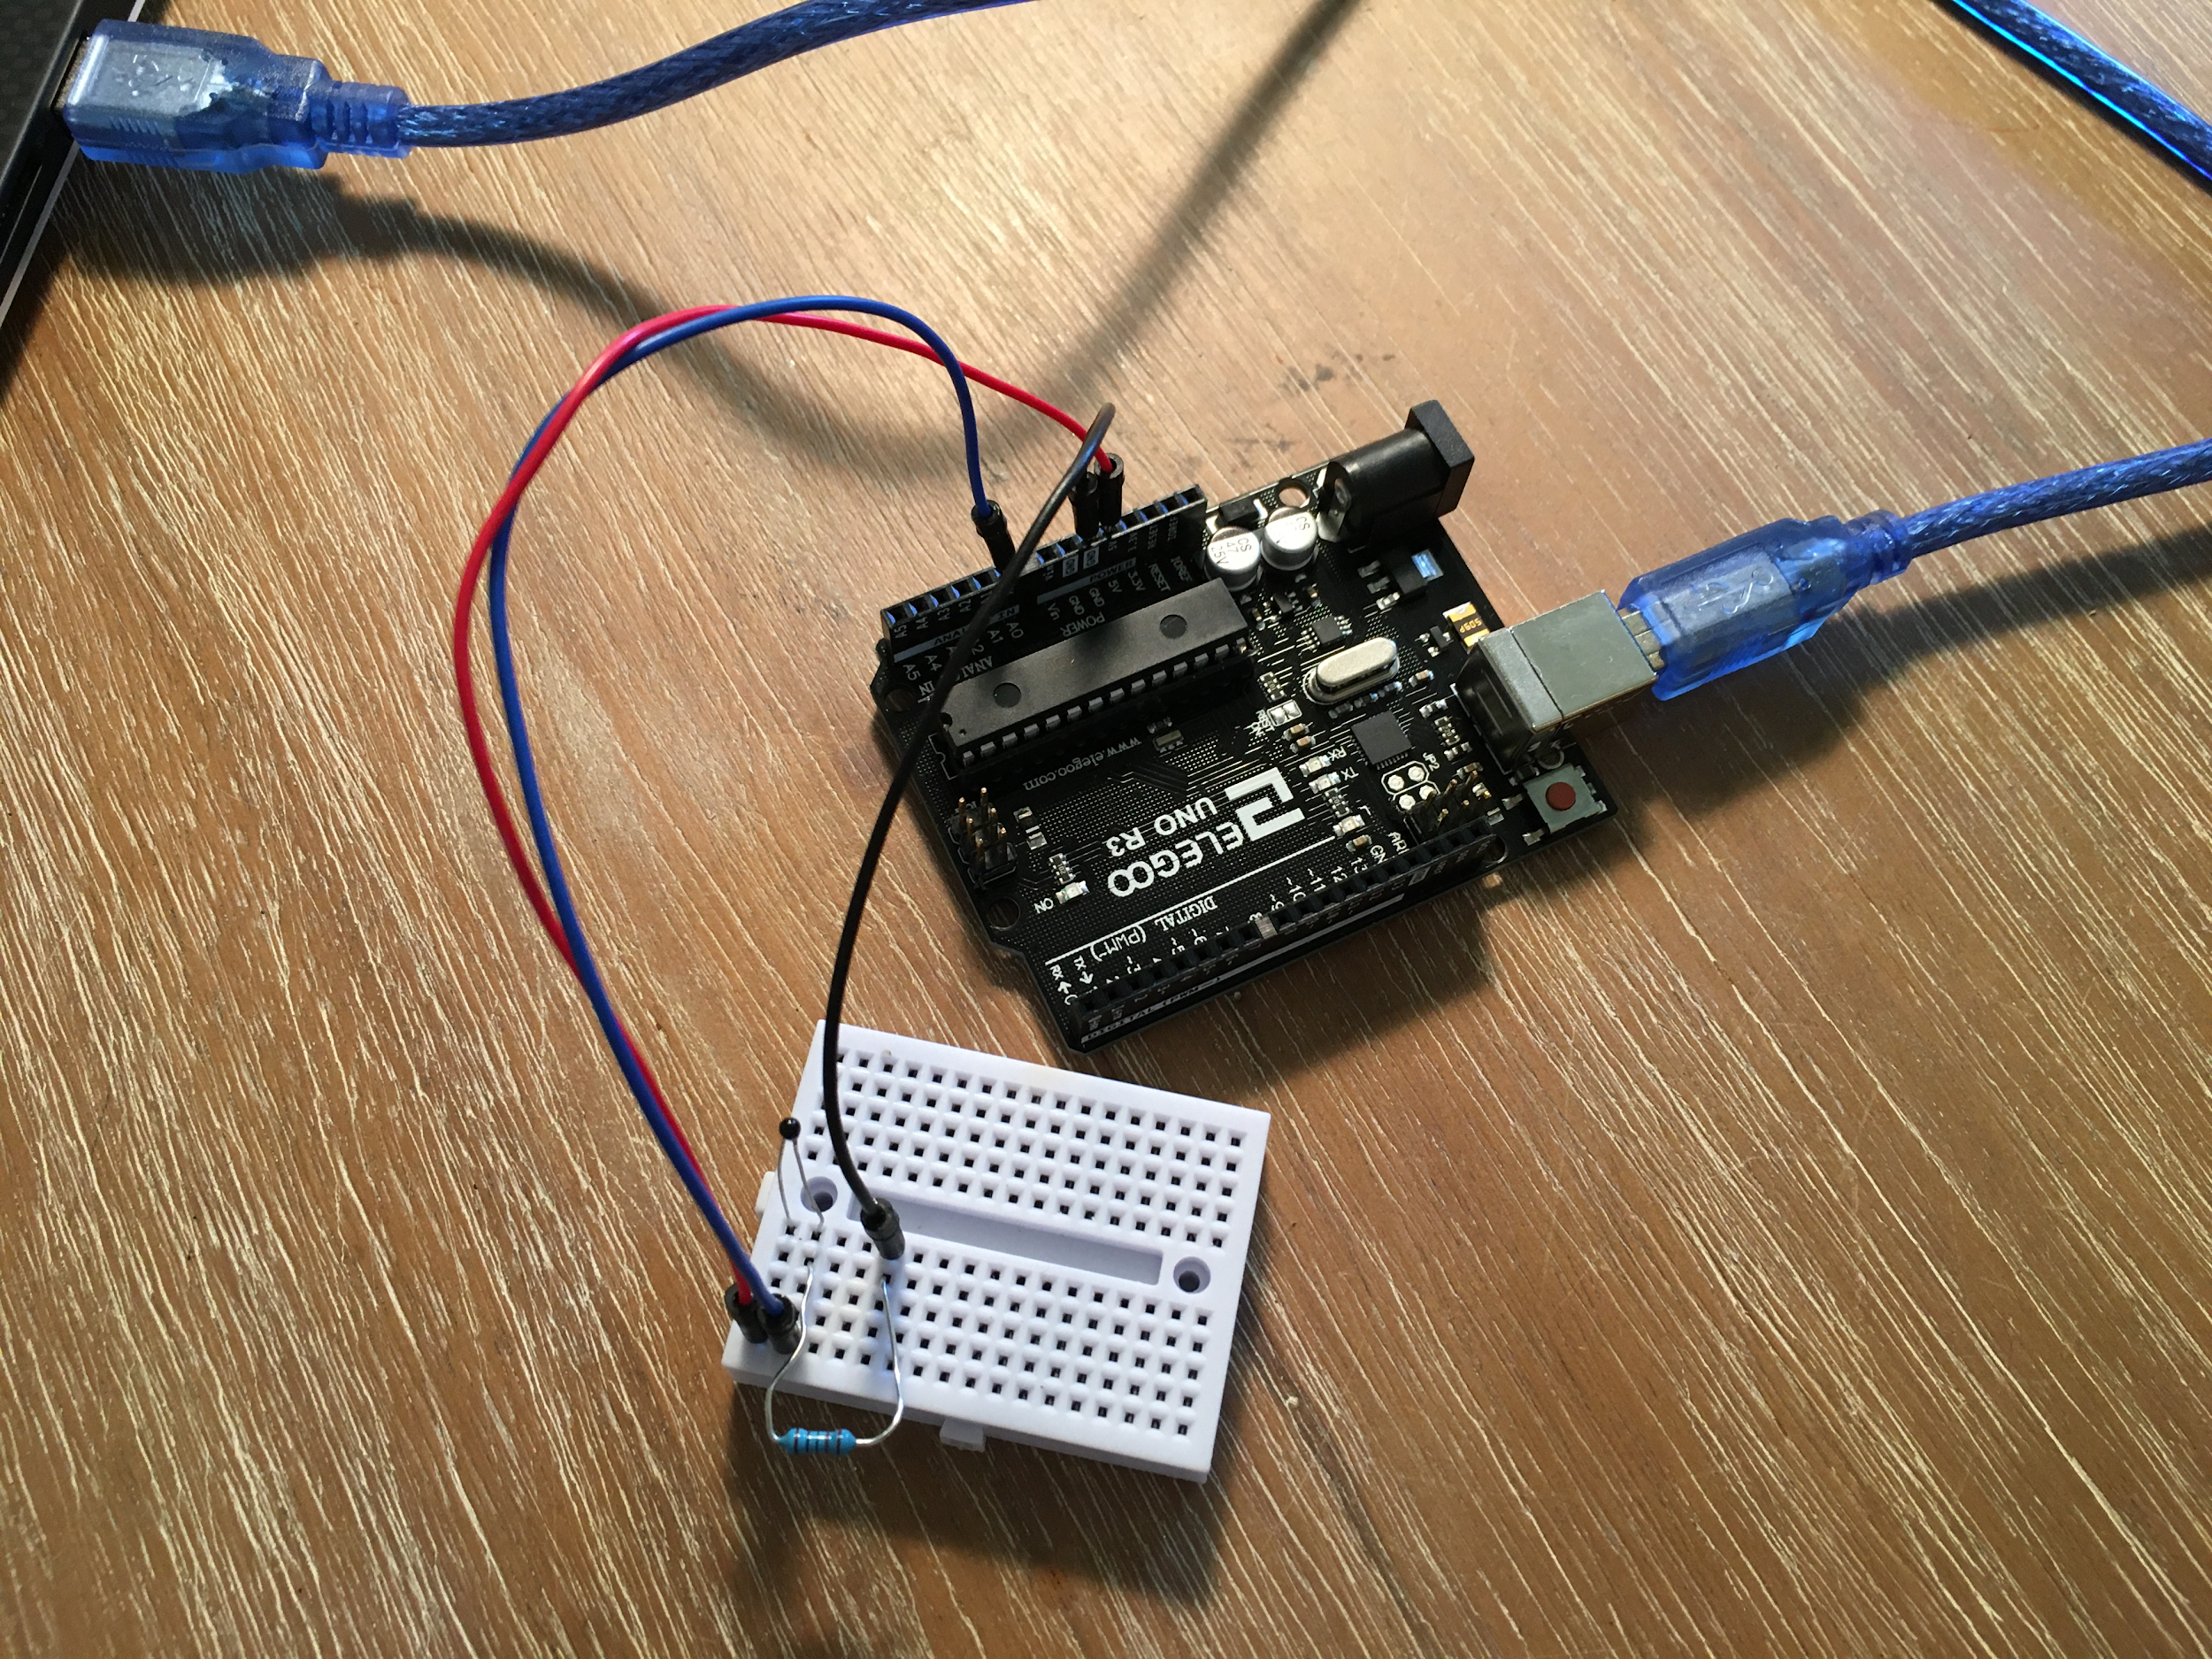

Please use the attached code or copy-paste the following Arduino code into a blank Arduino IDE sketch to start reading your thermistor values (**note: there’s no code to modify here**):

int tempPin = A0; // initialize the Analog Pin to read the Thermistor

int tempReading = 0; // initialize temp reading variable

double tempK = 0.0;

float tempC = 0.0;

float tempF = 0.0;

long curtime = 0;

void setup() {

Serial.begin(9600); // initialize the serial connection for data collection

}

void loop() {

tempReading = analogRead(tempPin); // read the analog pin connected to the thermistor output

// below is the algorithm based on the data sheet and calibration to convert voltage reading to temperature in Kelvin

tempK = log(10000.0 * ((1024.0 / tempReading - 1)));

tempK = 1 / (0.001129148 + (0.000234125 + (0.0000000876741 * tempK * tempK )) * tempK );

tempC = tempK - 273.15; // conversion from Kelvin to Celcius

tempF = (tempC * 9.0)/ 5.0 + 32.0; // conversion from Kelvin to Fahrenheit

curtime = millis(); // variable to keep track of sample time (if needed for data processing)

Serial.print(curtime); Serial.print(","); // print current time to keep track of sample time (if needed for data processing), with a comma delimeter to separate values

Serial.println(tempC); // print thermistor temperature in Celcius

delay(500); // this delay slows the code down so the data collects slower and is more readable

}

Once you have the circuit setup and the code uploaded and running, open the Serial Monitor to make sure that the sensor is reading properly (it should be nominally reading room temperature, which is around 23-25 degrees C). Then, open the Serial Monitor in the Arduino IDE, watch the data for a few seconds, and touch/pinch the thermistor for a few seconds to watch it heat up to your hand temperature, then release it and watch it return to room temperature. If your fingers aren’t achieving a reliable temperature increase, try using another heater source or move the circuit outside from inside and vice-versa.

***Note how the temperature readings do not instantaneously jump to new values!*** It takes time for a temperature reading to reach the correct value due to thermal conduction, convection, and resistance - you’ll learn more about thermal phenomena in Heat Transfer!

**Now let’s collect data from the Thermistor sensor over a 10 min. period into a data file. You will need to collect 10 min. of temperature data and paste the plotted data in the deliverables on pg. 1-2.** First, start the data collection (see next paragraph) and move your laptop and sensor electronics in your refrigerator or freezer for 5 min, then bring it back to room temperature and record the temperature data for another 5 min. Make sure that you’ve successfully captured the data and then plot the data in Matlab (note that the data was collected in 0.5 second intervals due to the 500 ms delay to help create your time x-axis array). Using the Matlab data and plots, estimate how long it took for the Thermistor to cool to the minimum temperature value when moving it from room temp to cool temp and to heat it back up from the cool temp to the room temp value. Was there a difference? If so, why do you think there might be a difference?

For temperature data collection over 10 min, here are two options:

Option 1 (best). **Use the real-time Arduino-Matlab data plotter .m file in the assignment .zip file**. You might need to install the [Matlab Support Package for Arduino Hardware](https://www.mathworks.com/matlabcentral/fileexchange/47522-matlab-support-package-for-arduino-hardware) and **change the Serial Port based on your Arduino and computer interface** to get this code working. **Note that you can only have one Serial Communication line open at a time, so make sure to close out of the Arduino Serial Monitor/Plotter before connecting via Matlab**. This is a great example of how you can link Matlab and Arduino for real-time data processing, coding, and plotting. You can adjust the plot parameters in the code or use the workspace data generated by the code to create your own formatted plot.

Option 2 (backup). [This video](https://www.youtube.com/watch?v=xqdC__jZILk) and/or [this online tutorial](https://learn.sparkfun.com/tutorials/terminal-basics/coolterm-windows-mac-linux) can help you learn how to [download](https://freeware.the-meiers.org/) and use CoolTerm to capture Serial data from your Arduino directly to a text file so you can load the data into Matlab and create a formatted plot. Note that you cannot be connected to CoolTerm and your Arduino Serial Monitor/Plotter at the same time - you can only have one serial port connected at a time.

# Part 3

Here we’ll combine the Thermistor, Servo, and DC motor together onto a breadboard to create a simple temperature control circuit like you would find in a refrigerator or HVAC system. This circuit and code are essentially a simplified example of the refrigerator compartment cooling system in most refrigerator/freezer combo machines and thermostat-controlled HVAC systems. [This video shows what an actual refrigerator cooling duct and fan system looks like which draws cold air from the freezer to cool the refrigerator](https://youtu.be/UuxA96ry3Wg?t=393). We’re simulating this by having the servo open and close a flap to let cool air blown by a fan cool down an area which contains the thermistor temperature sensor.

The objective here is to heat the thermistor hotter than room temperature by touching it with your finger. Typical finger temperatures are around 80-90 degrees F or about 26-32 degrees C. We’ll pick a temperature just below your finger temperature as the threshold to trigger the cooling system by turning the servo 90 degrees (simulating a flap or a damper duct opening) and turning the DC motor fan on to cool the thermistor. This is similar to how a refrigerator and HVAC systems work.

Starter code is included in the attached file to help you guide your code development based on the example codes we’ve used so far. You shouldn’t need to modify the variables or void setup() at the top – all of the new code to include should go in the void loop().

**Note that you may need to adjust the threshold variable value at the top of the code depending on your hand temperature**. First, you should touch or pinch the thermistor and observe the values on the Serial Monitor/Plotter. Choose a threshold value based on your hand temperature such that the threshold is about 2-3 degrees C lower than your hand or heat source temperature value to ensure that the temperature control circuit is triggered after you touch the thermistor and heat it up for a short time.

**Also, make sure that the fan is held or positioned close to the thermistor to help it cool down more quickly**. Time how long it takes for the thermistor to cool down without the fan vs. with the fan. Why does the fan help the thermistor cool more quickly (hint: do a little research on “thermal convection”)? **To complete the simulation, tape a piece of paper or cardboard onto the Servo arm you attach to the servo** [**as a flap to “block” the fan in between a combo freezer and refrigerator system**](https://youtu.be/UuxA96ry3Wg?t=393)**.**

**You will be submitting a video for Part 3 (put video link in deliverables on pg. 1-2)**. In your video submission, please make sure to show your face, demonstrate the working code and circuit, and show/discuss the results shown in the Serial Plotter.

Wiring Diagram:

